Change Management

Objectives:
At the end of the sequence, participants:
- Will understand the importance of controlling changes
- Will be able to identify the main steps of the process and their aims

This sequence is to be built locally. To this end, 2 options are available to you:
- either a local (or branch) training exists and meets these objectives. In this case, it can be used instead of this module.
- If this is not the case, we recommend you build your own training session by following the suggestions below.

This document contains content suggestions and educational activities to achieve the goals of this module.

Key elements | Support/activities
Controlling changes is paramount in safeguarding the safety barriers.  A clear and robust process must be implemented. | Golden rule 11 + occupation/branch regulation  Focus on a recent on-site change.

Estimated duration:

1 hour 30 minutes to 2 hours (in classroom) + visit

Teaching method recommendations:

This module works on the change process, starting with the branch or occupation regulation, and then reinforcing this process using a change implemented on-site, working on the amendment file and then carrying out an observation. Finally, an interview is planned to see the real effects on-site.
- Pre-requisite modules for the sequence
- TCG
- TCAS
- TCT 4
- Preparing the sequence
For the on-site part to be as efficient as possible, this module should be prepared in advance by selecting a change (with its file: risk analysis, procedures, work authorizations, audit, etc.) that has been recently implemented on-site. Ideally, this change will have visible effects on the process as well as on site organization (procedures, production/manufacturing capacities, organization of teams/schedules, etc.).

- Suggestion for sequence roll-out
Instructions legend for the trainer:
- Comments for the trainer
- Key content elements
- Type of activity
- “Question to ask”/statement of instructions

Phase/Timing | Trainer | Module content suggestion
- Welcome  15 minutes 15 minutes | Welcome participants and present the module's objective.  Show the video RC Golden Rule - Change Management.  Then ask:  You have already talked about golden rule no. 11 during your integration course:  "How should changes take place in a plant?"  "What protects against risks in the event of a change?" | Aim: At the end of the sequence, you will understand the importance of controlling changes.  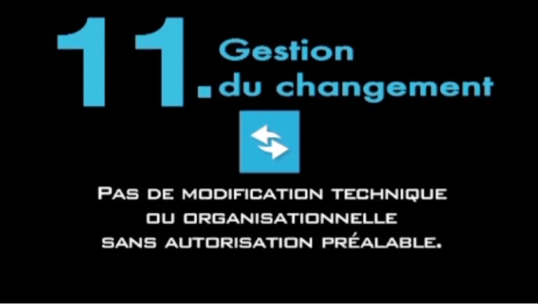
- Reminder of the golden rule  10 minutes 25 minutes | Everyone's roles.  Ask:  "What role can you play in managing change?"  Summary by the trainer on roles: Everyone has an important role to play in ensuring that changes are controlled, and that they all follow the required process. | Controlling changes is paramount in safeguarding the safety barriers.  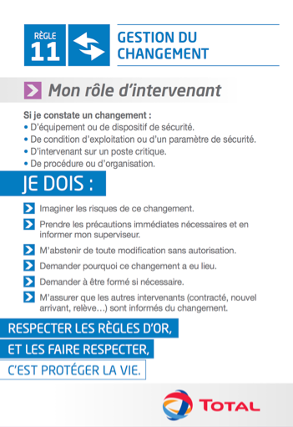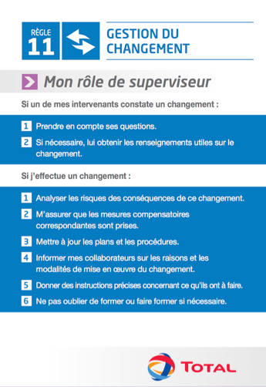
3. On-site application  30 minutes 55 minutes | Reinforce for the site/subsidiary  Read the occupation/branch/site/subsidiary regulation that applies to change management.  Workshop  List the steps of the process on the board in the incorrect order.  Then ask participants, in pairs, to use the branch/occupation regulation to put the process steps in the correct order.  Have a group come up to the board to give their order and have the other groups correct it if necessary.  Then ask:  How would you sum up the aim of each step? | - Occupation/branch regulation -  - Occupation process -
4. Reinforcement based on an effective change (or one in progress).  35 minutes 01:30 | To establish the link with the impact on the site, browse through an amendment file (created at your site/subsidiary) with the participants.  Distribute this file to the participants, and ask them to identify the main steps so they can establish the link with the previous exercise. | - An amendment file for the subsidiary -
5. Site/subsidiary visit: Estimated duration: 30 minutes to 1 hour depending on the site/subsidiary. | Organize a guided site/subsidiary visit to observe the specific effects of the change, and so people can testify to the change made (before/after).  Encourage the participants to ask the main contacts any questions, for example:  “What brought about this change?”  What has changed for you since the change?  Are the risks better controlled after this change?  On returning to the classroom, summarize on: “The importance of the change management process in maintaining the integrity of the plants, particularly where safety barriers are concerned.”

